1. **Introduction:**

At the start of our project you will get three menus to choose from. The first is the Indian menu, the second is the Chinese menu and the third is the Italian. So the users have to choose 0, 1 or 2 to get to the respective menu. Suppose they have chosen 2. Then the Italian menu will be displayed. Then you have press the respective number from 0 to 4 to order your dish. Then it asks for the quantity that you want to order. After you have entered the quantity it displays the total and it displays the message: press y to order some more food. If you press ‘y’ it displays the 3 menus again. But if you press anything other than ‘y’ the program displays your grand total and the program ends.

1. **Concepts used in Project**
   1. Array
   2. do – while
   3. if statements
   4. goto
   5. switch
   6. Function
2. **Concept description with syntax and example**
   1. Array:

An array is a collection of data items, all of the same data type, accessed using a common name. Types array are

1. *One Dimensional Array:* A list of items can be given one variable name using only one subscript and such a variable is called single sub-scripted variable or one dimensional array.

Syntax: datatype array-name[size];

Example:

* float height [50];
* int group [10];
* char name [10];

1. *Two Dimensional Array:* Two-dimensional array are those type of array, which has finite number of rows and finite number of columns.

Syntax: datatype array-name [row size] [column size];

Example:

int dips [2][4] = {

{10, 11, 12, 13},

{14, 15, 16, 17}

};

* 1. Do – While:

Do – While loop is a control flow statement that executes a block of code

at least once, and then repeatedly executes the loop, or not, depending on a given condition at the

end of the loop. Do – While is often also known as a post-test loop.

Syntax: do {

statements;

} while (condition);

Example:

int counter = 5;

int factorial = 1;

do {

factorial *= counter--;

} while (counter > 0);

printf ("factorial of 5 is %d\n", factorial);

* 1. if Statements:

“if” statement carries out a logical test and then takes one of two possible action depending on the outcome of the test (i.e. the outcome is true or false).

Types of if statements:

1. Simple if:

Syntax: if (expression)

Statement;

Example:

int n;

printf ("Enter an integer: ");

scanf ("%d", &number);

if (n> 0)

{

printf ("You entered %d.\n which is positive", n);

}

1. if-else:

Syntax: if (expression)

statement1;

else

statement2;

Example:

int number;

printf ("Enter an integer: ");

scanf (“%d",&number);

if (number%2 == 0)

printf ("%d is an even integer.", number);

else

printf ("%d is an odd integer.", number);

1. else-if ladder:

Syntax: if e1 s1;

else if e2 s2;

else if e3 s3;

Example:

int marks;

printf ("Enter your marks between 0-100\n");

scanf ("%d", &marks);

if (marks >= 90)

printf ("YOUR GRADE: A\n");

else if (marks >= 70 && marks < 90)

printf ("YOUR GRADE: B\n");

else if (marks >= 50 && marks < 70)

printf ("YOUR GRADE: C\n");

else

printf ("YOUR GRADE: Failed\n");

* 1. goto:

A goto statement in C programming provides an unconditional jump from the 'goto' to a labeled statement in the same function.

Syntax:

goto label;

..

.

label: statement;

Example:

int age;

Vote:

printf ("you are eligible for voting");

NoVote:

printf ("you are not eligible to vote");

printf ("Enter you age:");

scanf ("%d", &age);

if(age>=18)

goto Vote;

else

goto NoVote;

* 1. switch:

A switch statement is a type of selection control mechanism used to allow the value of a variable or expression to change the control flow of program execution via a multiway branch.

Syntax: switch (expression)

{

case value1: statement1;

break;

case value2: statement2;

break;

case value3: statement3;

break;

case default: default-block;

break;

}

Example:

int num=2;

switch(num+2)

{

case 1:

printf("Case1: Value is: %d", num);

case 2:

printf("Case1: Value is: %d", num);

case 3:

printf("Case1: Value is: %d", num);

default:

printf("Default: Value is: %d", num);

}

* 1. Function:

A function is a group of statements that together perform a task. Every C program has at least one function, which is main(), and all the most trivial programs can define additional functions.

You can divide up your code into separate functions. How you divide up your code among different functions is up to you, but logically the division is such that each function performs a specific task.

A function declaration tells the compiler about a function's name, return type, and parameters. A function definition provides the actual body of the function.

Defining a Function:

return_datatype function_name( parameter list ) {

body of the function

}

Example:

int max (int num1, int num2) {

int result;

if (num1 > num2)

result = num1;

else

result = num2;

return result;

}

1. **Code Segment:**
2. #include<stdio.h>
3. #include<string.h>
4. char indianDishes[5][15]={{"Biryani"},{"Dosa"},{"Samosa"},{"Tandoori"},{"Palak Paneer"} };
5. char chineseDishes[5][15] = {{"Noodles"},{"Fried Rice"},{"Dumplings"},{"Spring Rolls"},{"Mushroom Soup"}};
6. char italianDishes[5][15] = {{"Pizza"},{"Pasta"},{"Spaghetti"},{"Lasagna"},{"Meat Balls"}};
7. int indianDishPrices[5] = {100,40,15,200,80};
8. int chineseDishPrices[5] = {40,45,50,70,60};
9. int italianDishPrices[5] = {300,100,110,200,80};
10. int choice , option , quantity=1,total=0,grandTotal=0 ;
11. char c;
12. char dish[5][15];
13. int price[5];
14. void displayMenu();
15. void calculateTotal();
16. void indianMenu();
17. void chineseMenu();
18. void italianMenu();
19. main(){
20. do{
21. label1: printf("\n--Menu--\n");
22. printf("Press 0 for Indian food \n");
23. printf("Press 1 for Chinese food \n");
24. printf("Press 2 for Italian food \n");
25. scanf("%d",&choice);
26. if(choice==0){
27. indianMenu();
28. }
29. else if(choice==1){
30. chineseMenu();
31. }
32. else if(choice==2){
33. italianMenu();
34. }
35. else{
36. printf("Please enter valid input \n");
37. goto label1;
38. }
39. printf("Press 'Y' to order more\n");
40. scanf("%c,&c");
41. c = getchar();
42. c= tolower(c);
43. }
44. while(c=='y');
45. printf("Your grand total is Rs %d\n" , grandTotal);
46. }
47. void displayMenu(){
48. int i;
49. switch(choice){
50. case 0:
51. for(i=0;i<5;i++){
52. strcpy(dish[i],indianDishes[i]);
53. price[i] = indianDishPrices[i];
54. }
55. break;
56. case 1:
57. for(i=0;i<5;i++){
58. strcpy(dish[i],chineseDishes[i]);
59. price[i] = chineseDishPrices[i];
60. }
61. break;
62. case 2:
63. for( i=0;i<5;i++){
64. strcpy(dish[i],italianDishes[i]);
65. price[i] = italianDishPrices[i];
66. }
67. break;
68. }
69. label2: for(i=0;i<5;i++){
70. printf("Press %d for %s - Rs %d \n",i,dish[i],price[i]);
71. }
72. scanf("%d",&option);
73. if(option<0 || option>4){
74. printf("Enter valid order\n");
75. goto label2;
76. }
77. label3: printf("How many?\n ");
78. scanf("%d",&quantity);
79. if(quantity<=0){
80. printf("Enter a valid quantity\n");
81. goto label3;
82. }
83. printf("You have ordered %d %s \n",quantity,dish[option]);
84. }
85. void calculateTotal(){
86. total = price[option]*quantity ;
87. printf("Your Total is Rs %d\n",total);
88. grandTotal = grandTotal+total;
89. }
90. void indianMenu(){
91. printf("--Indian Menu--\n");
92. displayMenu();
93. calculateTotal();
94. }
95. void chineseMenu(){
96. printf("--Chinese Menu--\n");
97. displayMenu();
98. calculateTotal();
99. }
100. void italianMenu(){
101. printf("--Italian Menu--\n");
102. displayMenu();
103. calculateTotal();
104. }
105. **Result Snapshot:**

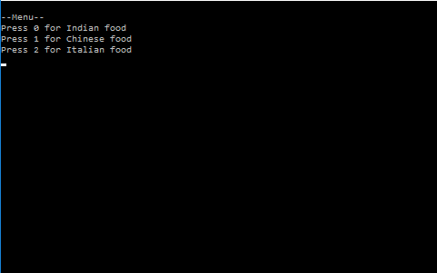

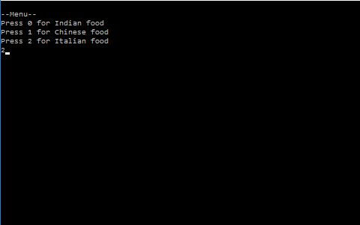

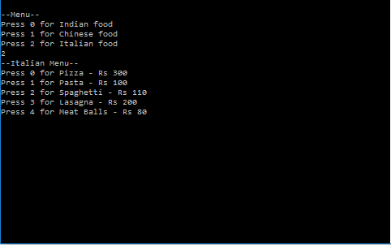

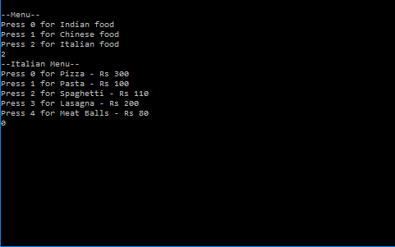

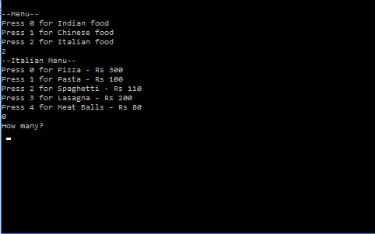

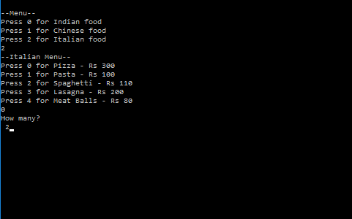

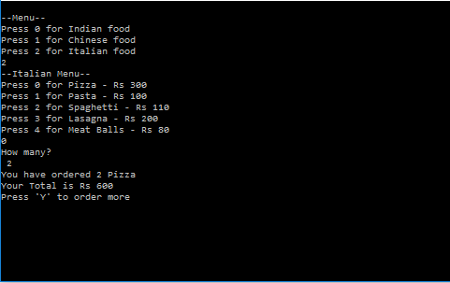

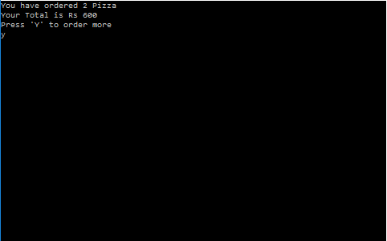

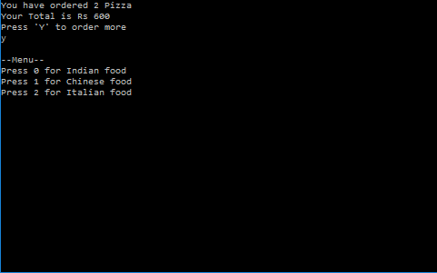

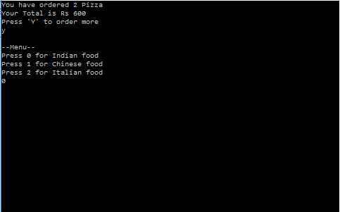

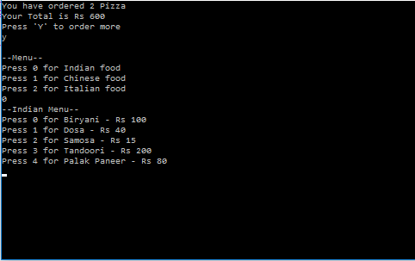

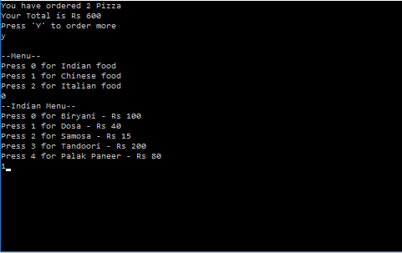

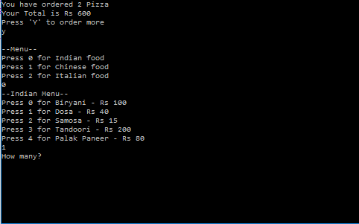

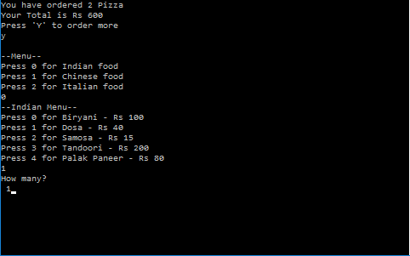

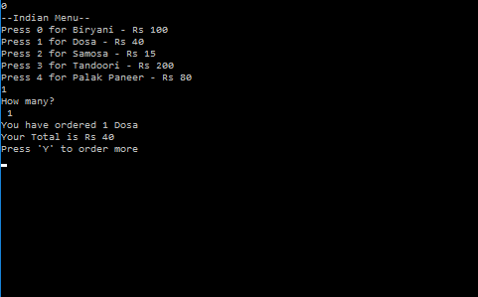

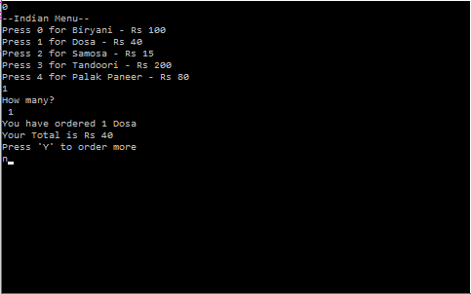

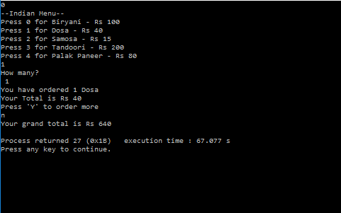

1. **Conclusion**

The primary goal of this project is to help customers to show the menu, order food and get their bill with a press of just a few buttons in order to save their time. It is a completely automated system and chef are just required to cook the food. And we think that this kind of system can be seen in almost every restaurant in the near future.

With this we are keeping one foot forward into the complete digital world.

**References**

1. www.wikipedia.com
2. www.tutorialspoint.com
3. www.programiz.com
4. Mrs. Napa Laxmi Notes
5. Mrs. Bhyagyashree Notes